Human rights

H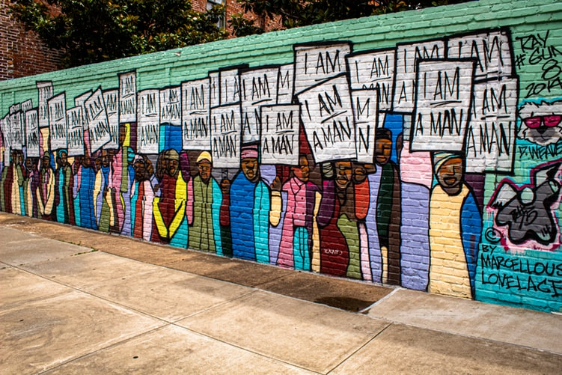

Moreover, human rights safeguard the interests of the citizens of a country. You are liable to have human rights if you’re a human being. They will help in giving you a good life full of happiness and prosperity.

Human Rights Categories

Human rights are essentially divided into two categories of civil and political rights, and social rights. This classification is important because it clears the concept of human rights further. Plus, they also make humans realize their role in different spheres.

When we talk about civil and [political rights](https://www.toppr.com/guides/general-knowledge/indian-constitution-fundamental-concepts/fundamental-rights-and-duties/), we refer to the classic rights of humans. These rights are responsible for limiting the government’s authority that may affect any individual’s independence. Furthermore, these rights allow humans to contribute to the involvement of the government. In addition to the determination of laws as well.

Next up, the social rights of people guide the government to encourage ways to plan various ways which will help in improving the life quality of citizens. All the governments of countries are responsible for ensuring the well-being of their citizens. Human rights help countries in doing so efficiently.

Importance of Human Rights

Human rights are extremely important for the overall development of a country and individuals on a personal level. If we take a look at the basic human rights, we see how there are right to life, the right to practice any religion, [freedom of movement](https://www.toppr.com/guides/general-knowledge/modern-indian-history/indian-freedom-movement/), freedom from movement and more. Each right plays a major role in the well-being of any human.

Right to life protects the lives of human beings. It ensures no one can kill you and thus safeguards your peace of mind. Subsequently, the freedom of thought and religion allows citizens to follow any religion they wish to. Moreover, it also means anyone can think freely.

Further, freedom of movement is helpful in people’s mobilization. It ensures no one is restricted from traveling and residing in any state of their choice. It allows you to grab opportunities wherever you wish to.

Next up, human rights also give you the right to a fair trial. Every human being has the right to move to the court where there will be impartial [decision making](https://www.toppr.com/guides/business-management-and-entrepreneurship/planning/principles-in-decision-making/). They can trust the court to give them justice when everything else fails.

Most importantly, humans are now free from any form of slavery. No other human being can indulge in slavery and make them their slaves. Further, humans are also free to speak and express their opinion.

In short, human rights are very essential for a happy living of human beings. However, these days they are violated endlessly and we need to come together to tackle this issue. The [governments](https://www.toppr.com/guides/civics/what-is-government/meaning-of-government/) and citizens must take efforts to protect each other and progress for the better. In other words, this will ensure happiness and prosperity all over the world.